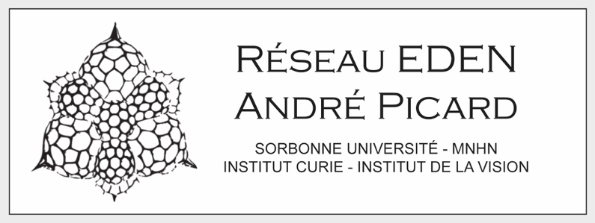

**Funding request for collaborative project (4000 €)**

**Research team 1**

Laboratory:

Research team:

Project applicant 1: (name, current position)

Three recent publications:

**Research team 2**

Laboratory:

Research team:

Project applicant 2: (name, current position)

Three recent publications:

Present shortly each team and their past collaboration (if any) – one page maximum.

**Details about the collaboration**

* Description of the collaborative project (1 page maximum), including the added value for the EDEN network.
* Publications (10 max) related to the project
* Detailed budget (half page maximum)

**Eligibility**

This call is open to open to all members of the EDEN network partner units (see list below) on all topics covered by the EDEN network (Evolution, Development and Environment). The project must however include (but do not need to be restricted to) concepts or approaches related to developmental biology.

This grant can either fund the stipend for a Master internship (4,35 €/per hour up to 6 months), consumables or travel expenses related to the collaborative project.

The collaborative teams can not belong to the same unit.

Projects involving a Master's student co-supervised between two teams from two partner units will be prioritized.

The successful applicants agree to give a talk at the next A. Picard days. To be held in Roscoff on March 9th and 10th 2026.

**Application deadline:** September 30th 2025

**Send applications as a single PDF to:** [lucas.leclere@obs-banyuls.fr](mailto:lucas.leclere@obs-banyuls.fr) and [jean-michel.gibert@sorbonne-universite.fr](mailto:jean-michel.gibert@sorbonne-universite.fr)

**List of EDEN network partner units**

- *Développement, Adaptation et Vieillissement,* UMR 8263 – Paris

- *Laboratoire de Biologie Intégrative des Modèles Marins,* UMR 8227 – Roscoff

- *Biologie Intégrative des Organismes Marins,* UMR 7232 – Banyuls-sur-Mer

- *Laboratoire de Biologie du Développement de Villefranche,* UMR 7009 – Villefranche-sur-Mer

- *Physiologie moléculaire et Adaptation,* UMR 7221 – Paris

- *Institut de systématique, évolution, biodiversité*, UMR 7205 – Paris

- *Biologie des organismes et des écosystèmes aquatiques*, UMR 8067 – Paris

- *Centre de recherche en paléontologie de Paris*, UMR 7207 – Paris

- *Dynamique du noyau* unit of the Curie Institute, UMR 3664 – Paris

- *L’Institut du cerveau,* UMR 7225 – Paris