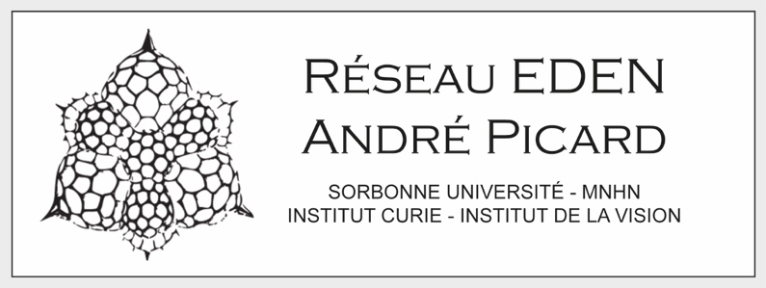

**Funding request for travel grant (500 €)**

**Conference/Summer school**

Participant name: Date:

Laboratory:

Research team:

Current position:

For PhD student, indicate which year (1, 2, 3 or 4):

**Type:** Conference/Summer school/Collaboration exchange

**Title:**

**Place:**

**and Date:**

**Details about the conference/summer school exchange**

Please detail below what will the interest of your participation to this event be for you, but also for the network Réseau André Picard/EDEN.

In case of conference, please indicate if you will present a poster or give a talk, and give its anticipated title.

(half-page max, in English).

**Publications (3 max) related to your request**

**The successful applicant agree to give a talk at the next A. Picard days**

*To be held in Roscoff 9-10 March 2026, mission covered by the network.*

**Eligibility:**

This call is open to open to all members of the unit partners of the EDEN network.

Applications from PhD students will be prioritized.

This travel grant can either fund the participation to an international conference or a participation to a summer school.

**Application deadline:** ?

**Send applications to:** [lucas.leclere@obs-banyuls.fr](mailto:lucas.leclere@obs-banyuls.fr) and [jean-michel.gibert@sorbonne-universite.fr](mailto:jean-michel.gibert@sorbonne-universite.fr)